**National University of Computer & Emerging Sciences (NUCES) Islamabad,**

Department of Computer Science

**DATA STRUCTURES – FALL 2023**

**LAB 07**

**Lab Task: Stack Implementation and Sorting/Searching**

**Objective:** To implement a stack data structure using linked lists and learn sorting and searching algorithms.

NOTE: MENU-BASED PROGRAMS.

**Task 01: Stack Implementation using Linked List (25 minutes)**

Implement the basic operations of a stack using a linked list.

* + **Stack()**: Constructor that creates an empty stack.
  + **push()**: Pushes an element onto the stack.
  + **pop()**: Pops the top element from the stack.
  + **peek()**: Returns the value of the element at the top of the stack.
  + **isEmpty()**: Returns True if the stack is empty, else returns False.

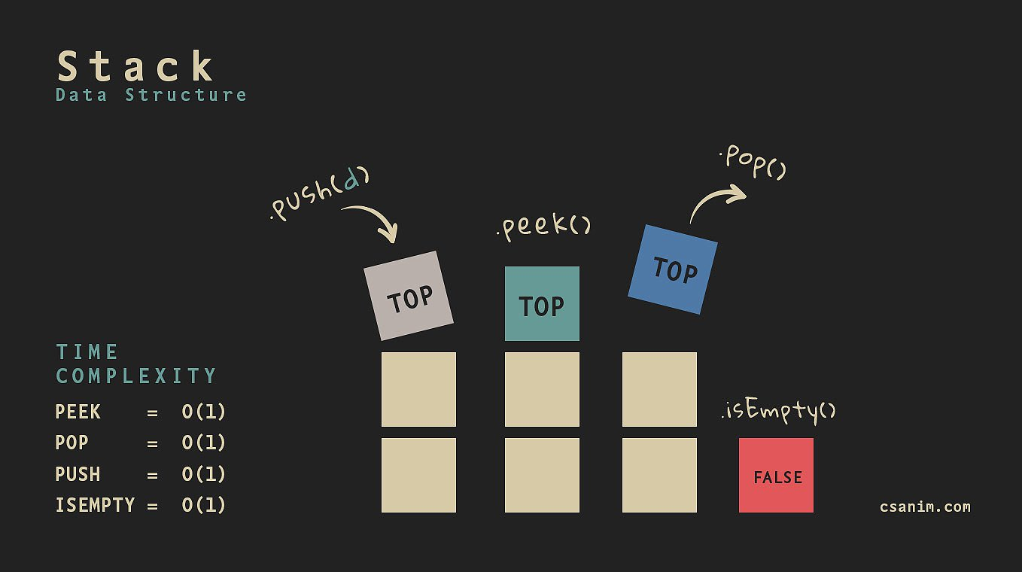

**Task 02: Sorting and Searching using Stack (30 minutes)**

1. **Read a given CSV file using file handling:**
   * Open and read the CSV file.
2. **Create a Student class and data members according to the CSV file:**
   * Define a class to represent a student and create data members that match the CSV columns.
3. **Implement constructors and setter/getter methods accordingly:**
   * Define constructors and accessor methods for the Student class.
4. **Push the elements into Stack:**
   * Store student objects in a stack data structure.
5. **Create an array named stdData and add all student objects to this array from the Stack:**
   * Transfer student objects from the stack to an array.
6. **Load CSV file:**
   * Load the CSV file, separated for clarity in the menu.
7. **Use a sorting algorithm to sort your array based on attributes like "Roll No," "Name," "As:1," "As:2," etc.**
   * Select an attribute and sort the array accordingly.
8. **Create a separate function for sorting by each attribute and save a separate sorted CSV file for each attribute:**
   * Implement sorting functions for various attributes and save sorted CSV files.
9. **Create a menu for this case accordingly:**
   * Design a user interface to select sorting attributes and execute the sorting and saving operations.

**Note:** The menu-based program should allow the user to select and perform each task independently and provide the necessary input and output as specified in the tasks.